Database assignments solution report
- Student id : 24110040
- Student name : Mahmoud Khaled AL-Azzeh
- Section number : section # 1

Table of Contents
Technical Documentation 3
1 Introduction 3
2 Database Requirement 3
2.1 User and System Requirement 3
2.2 Data Requirements 3
3 Database Design 3
3.1 Conceptual Design 3
3.2 Schema and Mapping 3
3.3 Logical Design 4
3.4 Physical Design 4
3.5 Effectiveness of the design 4
4 Normalization 4
4.1 1st NF 4
4.2 2nd NF 4
4.3 3rd NF 5
5 Physical Schema 5
6 Database Development 5
6.1 Database Overview 5
6.2 DML Commands 6
6.3 Security 7
6.4 User Interface 7
6.4.1 Flowchart and Data Movement Diagrams 7
6.4.2 Interfaces Development 7
7 Maintenance 7
7.1 Database recovery & backups 7
7.2 Database maintenance in general 8
8 Testing 8
8.1 Data Validation 8
8.2 Output Validation 8
8.3 Security Validation 9
8.4 GUI Validation 9
8.5 Assess whether meaningful data has been extracted 10
8.6 Assess the effectiveness of testing 10
9 Evaluation of database solution 10
9.1 Effectiveness of the database solution based on user and system requirement 10
9.2 Suggested improvements 10
9.3 Evaluation based on improvements needed 10
10 User Documentation 10
10.1 System Overview 10
10.2 Using the system 10
10.3 Frequently asked questions 10
10.4 Contact information 10

Technical Documentation

Introduction
This document explain the specific details for the university student transportation bus system , which a relational DB solution developed as part of HTU project for Crown Prince Award aligned with the ministry of transportation regarding the best government app for 2026 , which will consist of flexible and scalable infrastructure made to improve the private and public transportation services , although this DB will provide the daily operations of university students commuting , handling main elements like : student registration , bus fleet details , daily trip scheduling and passenger booking , which all these data will become digitalized so the system will ensure greater accuracy safety and operational flexibility for administrators and students .
The main aim from this technical documentation is to have a comprehensive blueprint for the transportation system architecture , development and validation , which all stakeholders and developers will be provided with the sufficient data for how the DB fulfils both user and system requirements while taking scalability and integrity into consideration , which also will include detailed DB phases like : conceptual , logical and physical schemas alongside through mapping and normalization , furthermore it outlines the practical development of the DB including SQL , security , privileges implementation , user interface flowcharts , maintenance protocols and system testing to guarantee optimal performance .

Database Requirement

User and System Requirement

- user requirements :
these are the possible users that can use the university student transportation system and its services :
- Students (passengers ) :
- Register their personal and financial details .
- View available bus routes , trips and departure times .
- Book seats on specific chosen trip .
- Update and check their current booked reserved trip .

- Administrators (system managers) :
- Mange each bus fleets : adding , updating or removing bus info and accepted capacity for each one .
- Monitor and update each bus licences data to ensure compliance and legal transportation.
- Daily scheduling and planning routes .
- Authorized viewing for passenger reservation to ensure capacities .

- System requirements :
Required to have a comprehensive system that operated to ensure effectiveness :
- Flexibility and adaptability : the system should be as flexible as possible that can adapt to students transportation records easily handles updates on trips or bus sizes.
- Accuracy and safety : it must ensure the data accuracy and safety operations which will help in preventing the overbooking or even will ensure all active buses on the system have valid reservation dates.
- User friendly : the DB must be connected to user friendly graphical user interface so users can perform easily using the system which allow them to navigate schedules and administrators to monitor all routes and other complex technical data .
- Data quality and integrity : the system must have consistency in data, high quality and reliable by ensuring strict validation rules and constraints.
- Security : the system must implement security measures to ensure that each type of user can perform regarding its own privileges and specific roles .

Data Requirements

- As a normal transportation system it will store records regarding registered students , so each student will have ID , full name ( the first and last name ) as well as their contact info like mobile number keeping in mind that single student may have multiple of mobile number related to him .
- Also the system will monitor the fleet of buses , so every vehicle will be identified with an ID other important details like the maximum capacity for each of them and specific model of the vehicle.
- Official licensing documents is recorded as registration, so each one will be documented and identified using ID and other elements like plate number and license expiry date.
- Scheduled journeys will recorded as trips entities , so each one have a unique ID and other details like : trip name , date , and starting time excluding the finish time.
- Each bus has exactly one active registration document and each document related to only one bus (1:1 cardinality relation).
- Each bus can operates over multiple of trips across the whole semester bur each scheduled trip is assigned to exactly one bus (1:M cardinality relation ).
- A student can reserve multiple of trips over the weak and each trip can also have multiple of students on board (M:N cardinality relation ).

Database Design

Conceptual Design
Definition : this design is the highest level and abstract view of DB system . it shows the semantic model that clarifies the real world data and how elements of it interact , without caring about how any other DBMS or technical implementation details operates .
Goals : is to capture and perceive the business requirements in an easy and understandable way , for technical developers and other non technical stakeholders like administrators.
Main Component : the components include entities (real world object represented by a rectangle) , attributes (the characteristics of these entities represented by ovals) and relationships (the logical linkers between entities represented by diamonds which include cardinalities and other constraints).
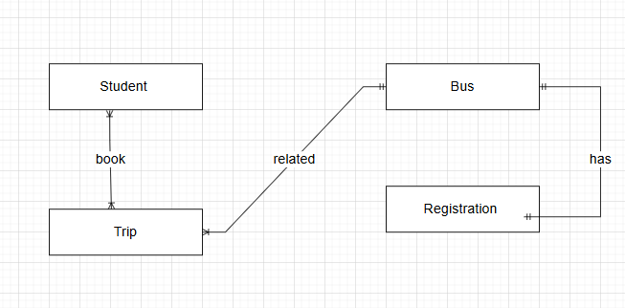

Brief : this conceptual diagram demonstrates four key relationships the first one (1:1) between bus and registration , which each bus van have only one licensing registration document and each document related to only one bus. The second one (1:M) between the bus and the trip which each bus can have multiple trips but each trip is related only to one bus , third one (M:N) between student and trip which each student can reserve multiple trips and each trip have multiple student .

Schema and Mapping
First step :
mapping the regular entities , we will create initial relations as tables for all the strong entities shown in the previous conceptual design and assigning their simple attributes and primary keys.
- Before : the conceptual entities : student , bus , trip and registration exists independently with their attributes.
- After : after the first mapping ,

Students (StudentID (PK) , FullName , phone , Email , Nationality , Address , Parent_ Contact) .
Bus (BusID (PK) , capacity , Model , Brand , Color ) .
Registration (RegID (PK) , licensePlate , ExpityDate ) .
Trip (TripID (PK) , tripdate , starttime , EndTime ,RouteFrom , RouteTo ) .

Step two :
Mapping the composite attributes : composite values will be broken down into simple , atomic attributes to ensure data integrity .
- Before : student table attributes as following : (StudentID (PK) , Name , Phone) .
- After : we must break the name attributes into two fields the first for the first name and the second for the second name.
Student : (StudentID (PK) FirstName , LastName , Phone , Email , , Nationality , Address , Parent_ Contact ).

Step three :
Mapping for multivalued attributes : this kind of DB such as relational cannot handle multi values in a one single column , so we will remove this value to a separate table and then relink it to the original table .
- Before : Student (StudentID (PK) , FirstName , LastName , Phone , Email , Nationality , Address , Parent_ Contact ) .
- After : we will remove the Phone attribute from student table into another separate table to create a relation with Student_Phone table so the primary key will be as a composite key which is StudentID and Phone number .
Student (StudentID (PK) , firstname , lastname , Email , Nationality , Address , Parent_ Contact ) .
Student_Phone (StudentID (PK, FK) , PhoneNumber (PK) ) .

Step four :
We will map the relation categorized under (1:1) between bus and registration , so we will take the primary key of one table and insert in into the other as a foreign key then we place the PK busID into the other table registration to identify that this table belongs to a specific bus.
- Before : Bus (BusID , capacity , Model , Brand , Color) .
Registration (RegID (PK) , licensePlate , ExpiryDate ) .
- After : we will add BusID as a FK to the other registration table , and it must b marked as Unique to enforce the strict (1:1) .
Registration (RegID (PK) , licensePlate , ExpiryDate , BusID (FK , Unique ) ) .

Step five :
We will map the (1:M) relation between Bus and trip , so we must take the PK Bus table and add it to the other trip table as a FK .
- Before : bus (BusID (PK) , Capacity , Model , Brand , Color ) .
Trip (TripID (PK) , routename , TripDate , StartTime , EndTime ,RouteFrom , RouteTo ) .
- After Trip table will become as the following :
Trip (TripID (PK), RouteName , TripDate , StartTime , EndTime ,RouteFrom , RouteTo , BusID (FK) ) .

Step sex :
The (M:N) many to many relationship can not be mapped between student and trip so the procedure will be as following :
We will create a new bridging table called Booking to break the initial table into two (1:M) relationships :
- Before : student and trip tables are independent , with a conceptual (M:N) action between them .
Student (StudentID (PK) , FirstName , LastName , Email , Nationality , Address , Parent_ Contact ) .
Trip (TripID (PK) , RouteName , TripDate , StartTime , EndTime ,RouteFrom , RouteTo , BusID(FK) ) .
- After : we must create a new table named Booking which it takes the PKs from both student and trip tables and assign them as FKs alongside its attribute.
Booking (BookingID , BookingDate , Status, StudentID (FK) , TripID (FK) ) .

Logical Design

Definition : it is a design where the process of translating the conceptual design to a structured , relational schema that can be handled by a relational DB system wile its independent from any DBMS like MySQL .
Goal : the primary goal is switching the normal entities into structured tables , resolving complex relationships like (M:N) and enforce data integrity.
Main Components : one of the main elements is the tables converted from entities , attributes columns that represent the objectives of data in multiple fields , primary keys which a unique identifiers for each record , and the foreign keys is a special attribute that used to link a primary keys in other table to establish relations between tables.

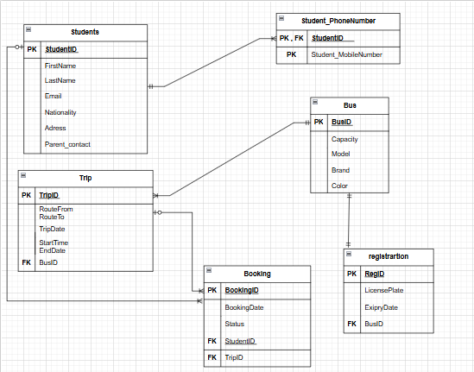

Brief : The previous figure shows each entity switches to a table which each one of the table belongs with it is attributes as shown , and also differ than the conceptual design by processing and handling the relations like (1:1) and link between the primary and foreign keys furthermore the (1:M) one to many relations and finally the complex (M:N) many to many relations that is processed through separating it into two (1:M) relationships and create booking table than links between student and trip which each student can make multiple bookings and each book related to one student the same as trip which each trip can have multiple bookings but each book related to one trip , so by this two (1:M) we solved the issue of (M:N) relations.

Physical Design

Definition : it is the design which is the final stage of DB design process , where the previous logical design where translated into a technical blueprint tailored for a specific DBMS assigned with the data types and constraints for pointed attributes .
Goal : the primary goal for this stage is to identify and define where exactly the data will be stored , organized and accessed on the physical storage media to ensure data integrity , performance and optimize multiple assigned rules .
Main Component : the main element is the actual tables for each entity built in the DBMS environment , where data types assigned to each attribute like (INT , VARCHER(X) , DATETIME ) , and other specific constraints like (NOT NULL , NULL , UNIQUE , CHECK ) , that dictates exactly what data is permitted in each column .

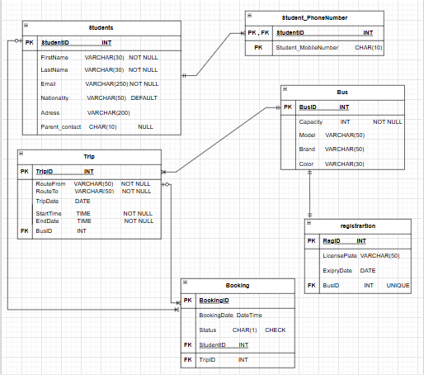

Brief : the previous figure show the last stage of designs which is the physical stage where the datatypes are assigned like VARCHAR(x) that can handle characters up to the chosen number unlike char(X) that only accept the exact chosen number of characters also INT that accept number and finally date and time that accept date consist of (year-month-days) , time that accepted (hours-minutes-seconds) and DATETIME accepts the two of them combined with each other for specific time lamps . and the constraints used for making the data more specific and organized like check that force the user to enter only the pointed value like the booking status even “R” for reserved , “E” empty ready for reservation , and unique that only accepts different values from each other furthermore not null that force the user to enter a value unlike null that the user can leave empty.

Effectiveness of the design

The DB design for the chosen system scenario was strategically integrated to address the transportation ministry goals , the initial required entities that are : students , bus , trip , registration where selected to line up on the core system operations , also other attributes where selected to meet the exact system needs for example capacity in the bus table where chosen to enable the students to only register up to the assigned capacity number , to meet the safety requirements for the transportation system. While the student phone number that is linked to the multi valued attributes to ensue a reliable communication , furthermore the relation between entities like : (1:1) relationship links the bus to the registration which each registration paper related to one bus , (1:M) relationship between bus and trip allow to organize and schedule multiple trips for each bus over time and finally the (M:N) relationship between students and trip accommodates the primary user requirement that each student can book multiple trips and each trip carry multiple students.
The conceptual design : it is the design where the clear and visual blueprint of business rules are provided targeted exactly at those non technical employees like the administration partners , however translation this into a functional DB schema aping was required to finalize the complex real world interactions most notably the many to many relationships where solved as shown previously , finally transforming a conceptual design into a structurally relational schema.
Upgrading the work in to the next level which is the logical design we add some structural mechanisms like : Primary and Foreign keys to ensure data integrity , BusID where assigned as a FK within the trip table to ensure that this bus is related to this trip , the physical design then where tailored this logic for the workbench by applying strict data types and constraints assigning DATETIME data type to the booking date to have a specific date and time for the reservation , and check constraints for the booking status .
To guarantee data integrity and prevent redundancies , the normalization was applied , so the first normal form (1NF) by ensuring all data was atomic , the multi valued like : phone attribute was split into another table named “Student_Phone” table so each number occupies a single row , secondly the (2NF) was achieved by removing partial dependencies like keeping the student name strictly in the table preventing depending on the composite primary key of the booking table , finally the third normal form (3NF) was met by removing the transitive dependencies like : putting the bus capacity inside the trip table would violate the 3rd form because capacity attribute depends totally on the bus not the trip so I keep it in the bus table only to prevent update anomalies.
At the end , the progress of mapping and the normalization steps ensures to get a DB seamlessly meets user and system requirements , by assigning physical constraints and referential integrity the system provides a highly accurate , flexible and safe infrastructure , so this encourage the students to book using this transportation system and let the administrators to calculate and manage fleet operations effectively.

Normalization

1st NF

Relations | Attributes | Violation description | Solution – Relations
The relations schema | The attribute name | Describe why it is not in the 1st NF (the violation) | Show the schema for each affected relation.
Unnormalized students table | Phone_Number | The phone number attribute it can have multiple phone numbers for each student that violates the first normalization which is every attribute can hold only one single value . | We will split the studentID as a PK , FK and phone number as a PK in another table :  Student_PhoneNumber : (studentID(pk,fk) , Student_PhoneNumber) .
Unnormalized trip table | Route | This attribute contains both the start and end location which also a composite that violates the first normalization for example (Amman To Zarqa) | We split the route column into two columns in the same table as a solution for thee composite key : trip : (TripID , Route_From , route_To , TripDate , StartTime , EndTime , BusID ).

2nd NF
Relations | FDs | Violation description | Solution – Relations
The relations schema | Show the functional dependencies causing the violation | Describe why it is not in the 2nd NF (the violation) | Show the schema for each affected relation.
Unnormalized booking  (booking) : bookingid(pk) , bookingdate , status(check) , studentid(fk), tripid(fk)  Assuming a composite PK of StudentID and TripID. | {StudentID , TripID} ->  {BookingID , status}  {studentID} -> {Email} | The email is a non key attribute that depends only on studentID which is one part of the composite PK key , this a partial dependency that violates the second normalization. | (students) : studentid(pk) , firstname, lastname, email, nationality(default Jordanian) , address, parent_contact (null) .  (booking) : bookingid(pk) , bookingdate , status(check) , studentid(fk), tripid(fk)
Unnormalized Student_PhoneNumber(StudentID , Student_PhoneNumber , FirstName). | {StudentID , Student_PhoneNumber} -> {}  {StudentID} -> {FirstName} | The column FirstName depends exclusively on the column studentID because it’s a part of the composite PK so creates a partial dependency. | (students) : studentid(pk) , firstname, lastname, email, nationality(default Jordanian) , address, parent_contact (null)  (student_phonenumber) : studentid(pk,fk) , student_mobilenumber(pk).

3rd NF
Relations | FDs | Violation description | Solution – Relations
The relations schema | Show the functional dependencies causing the violation | Describe why it is not in the 3rd NF (the violation) | Show the schema for each affected relation.
Unnormalized trip : (TipID , RouteFrom , RouteTo , TripDate , StartTime , EndTime , BusID , Capacity , Brand). | TripID -> BusID  BusID -> {capacity, brand}  Therefore :  TripID -> {capacity , brand} | The attributes capacity and brand which is non key attribute depends on BusID . another non-key attribute in this table), rather than the primary key TripID. This transitive dependency violates 3rd NF and causes update anomalies. | (bus) : busid(pk), capacity , model , brand , color .  (trip) : tripid(pk) ,routefrom, routeto , tripdate, starttime, endtime ,busid(fk) .
Unnormalized booking : BookingID, BookingDate, Status, StudentID, TripID, Email | BookingID -> StudentID  StudentID -> Email  Therefore :  BookingID -> Email | The non-key attribute email depends on the foreign key StudentID rather than the primary key of this table , bookingID. This is a classic transitive dependency. If a student changes their email, you would suffer an update anomaly, having to update every single booking they ever made. | (booking) : bookingid(pk) , bookingdate , status(check) , studentid(fk), tripid(fk) .  : (students) : studentid(pk) , firstname, lastname, email, nationality(default Jordanian) , address, parent_contact (null)

Physical Schema
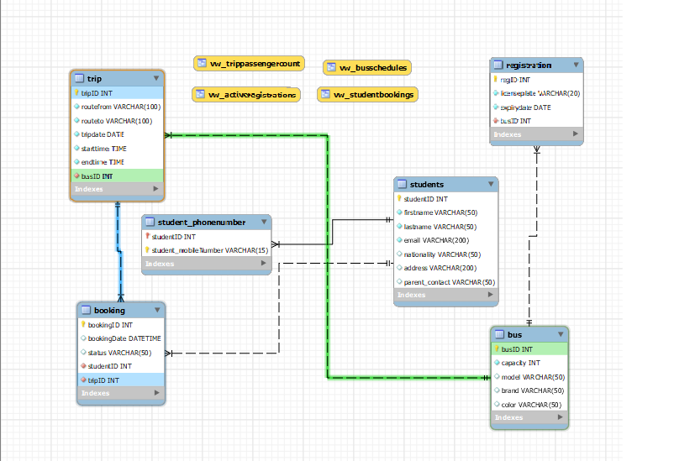

Database Development

Database Overview
Table | Name | SQL Command
 | Students | This table aims to store the core profile data for students (passengers) it utilize studentID (INT) as a PK with an auto_increment constraints for unique identification and includes other multiple attributes like : firstname , lastname , email (varchar with not null and unique constraints ) to ensure data integrity.
 | Student_phoneNumber | The purpose of this table to handle the multi valued attribute which is Student_PhoneNumber that allows each student to have multiple phone numbers that uses composite PK as studentID (serves as a foreign key connected to student table to maintain integrity) and student_phoneNumber .
 | Bus | We store the fleet information in this table , the primary key is busID (INT, auto_increment) also a capacity attribute with a check constraint to ensure that the value is greater than 0 , along side with model, brand , color attributes with a datatype (varchar) to identify the vehicles.
 | Registration | This table purpose is to store secure and sensitive documentation , it uses regID as a PK which is connected to the bus table with busID as a foreign key to enforce a 1:1 relationship , also the busID attribute has a unique constraint guaranteeing one registration per bus.
 | Trip | Journeys are mapped out using this table , it uses tripID as PK and other multiple attributes like : routefrom , routeto (varchar) and other temporal data types for tripdate , starttime ,endtime (date, time) and busID as a FK to connect to bus table as a 1:M relationship to ensure that each bus can handle multiple trips and each trip related to one bus.
 | Booking | This junction table process the complex relationship which is M:N between students and trip tables , it uses BookingID as a PK although it includes studentID and tripID as a FK to connect to their tables , it also have attributes to track reservation moments using datetime datatype for booking date attribute and other constraints like check for status to restrict entries between : “confirmed”,”pending”,”cancelled”

View | Name | SQL Command
 | vw_StudentBooking | This view aim to provide a readable schedule for each booked passengers , it is performed by using the students, booking and trip tables , sampling the complex junction logic of the tables so the students can easily access the info for their trips (routes and status).
 | vw_BusSchedules | This view aims to let the transportation mangers assist the fleet logistics by using the bus and trip tables together to display multiple vehicles details alongside with their daily operation hours preventing any conflicts.
 | vw_ActiveRegistration | This view aim to monitor and organize , by using the bus and registration tables to filter the existing expiry dates , users utilizing this view can instantly verify which vehicle are legally permitted to operate.
 | vw_TripPassengerCount | This view is made to calculate the operational KPIs it uses trip and booking tables , grouping the data by specific trip and using the count pre defined SQL aggregation function , which allows mangers and monitors to monitor exactly how many confirmed passenger on each trip to avoid overcapacity.

Procedure | Name | SQL Command
 | Sp_AddStudent | This procedure let use streamline the registration process of new users , procedure let you easily just input the students firstname , lastname and email instead of writing the complex insert queries and so the procedure safely insert the record directly by itself generating the new unique studentID.

 | Sp_CancelBooking | This procedure allow iteration in updated or modifying any reservations , for example when a student decide to drop a journey this procedure with its entire structured code commands will takes the BookingID and change the status to cancelled without deleting the historical record of the transaction.
 | SP_UpdateBusCapacity | This procedure helps the transportation managers to modify the bus data easily to hold more seats for example by providing the busID and the new capacity number ensuring the data in updated safely without altering any other vehicle details.
 | Sp_DeleteRegistration | This procedure used to keep the whole data utilized and maintained so if a registration document has expired or a bus has been sold this procedure by giving the regID can easily delete the registration record for the specifies bus.

DML Commands
Procedure | Name | SQL Command | Output Screenshot
 | Insert | CREATE PROCEDURE sp_AddStudent( IN p_fname VARCHAR(50),  IN p_lname VARCHAR(50), IN p_email VARCHAR(100) )  BEGIN  INSERT INTO Students (firstname, lastname, email)  VALUES (p_fname, p_lname, p_email);  END $$  call sp_AddStudent('mahmoud','azzeh','mahmoud2azzeh@gmail.com'); | 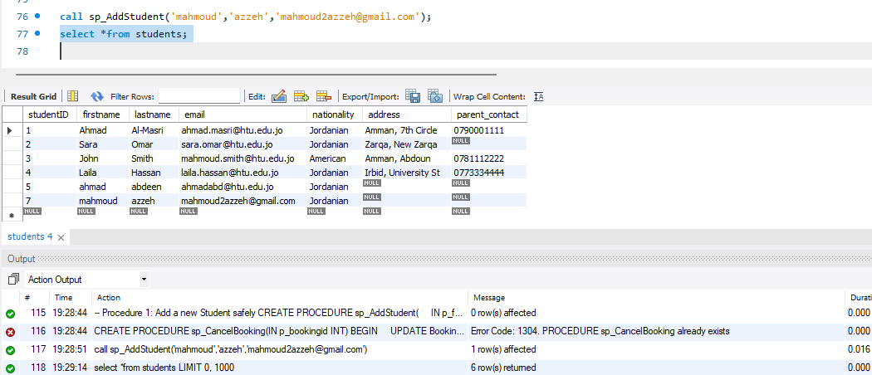
 | Update | CREATE PROCEDURE sp_UpdateBusCapacity(IN p_busid INT, IN p_newcapacity INT)  BEGIN  UPDATE Bus  SET capacity = p_newcapacity  WHERE busid = p_busid;  END $$  CALL sp_UpdateBusCapacity(1, 30); | 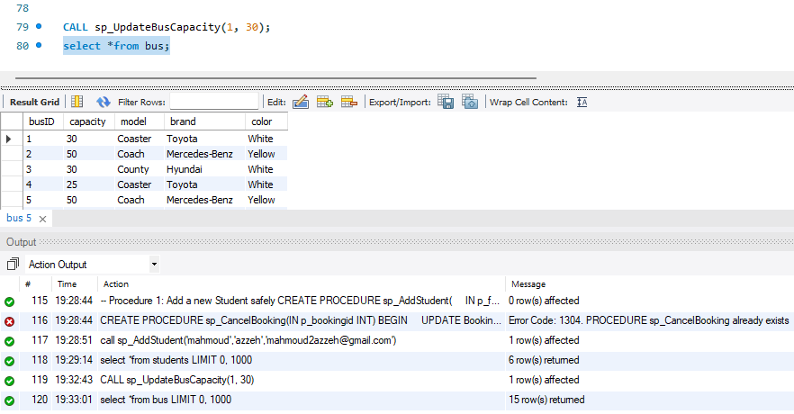
 | Delete | CREATE PROCEDURE sp_DeleteRegistration(IN p_regid INT)  BEGIN  DELETE FROM Registration  WHERE regid = p_regid;  END $$  DELIMITER ;  CALL sp_DeleteRegistration(2); | 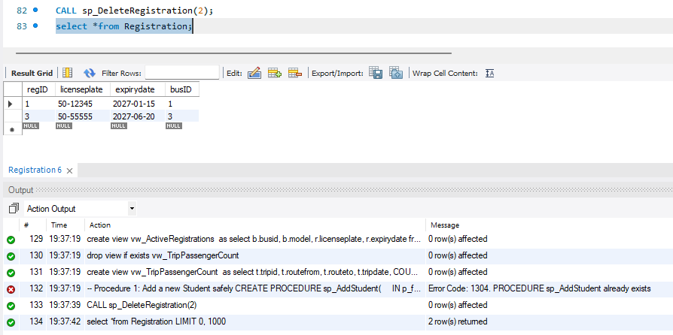

Security
User name | Privilege SQL Command | Description | Screenshot
Admin_user | GRANT ALL PRIVILEGES ON HTU_Transport.* TO 'Admin_User'@'localhost'; | The transportation system manager required a flexible access to manage fleet logistics and tracking , update buses , capacities , reviewing scheduling conflicts and maintain the registration tables , so this commands give him the access for all these operations. | 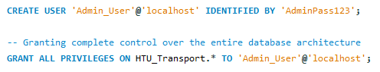
Student_user | Read and access data :  GRANT SELECT ON HTU_Transport.vw_StudentBookings TO 'Student_User'@'localhost';  GRANT SELECT ON HTU_Transport.vw_BusSchedules TO 'Student_User'@'localhost'; | By filling the user requirements the student can access bus schedules so by strictly accessing on the data by using select view rather than giving the full access on data so this protects the sensitive and private data like emails and addresses from general students which ensures privacy compliance. | 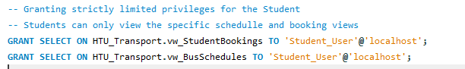
 | Write access : GRANT INSERT, UPDATE ON HTU_Transport.Booking TO 'Student_User'@'localhost'; | This meets the system requirements that let the students to reserve their own seats alone , and the delete operation was intentionally blocked , but student can also update on their already existing reservations status to “cancelled” without deleting the entire record which preserve auditing data for the transportation managers. | 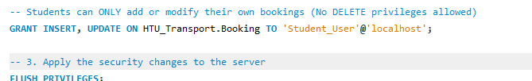

User Interface

Flowchart and Data Movement Diagrams

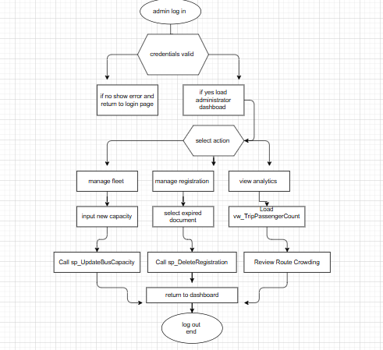
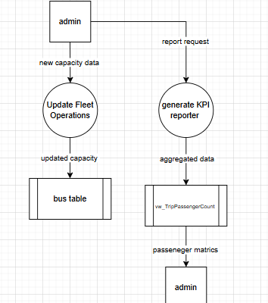
DFD : flowchart :

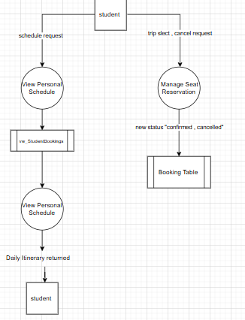

Interfaces Development

Page ID | Title | Description | Screenshot
 | Student homepage | Service : represent the central navigation part of the student portal , it will securely welcome the logged.  Actions : the user can use the main navigation menu or separate buttons to access the services , schedules , reservation, booking management and profile setting . it essentially routed the user interface interactions without dealing directly with the database tables. | 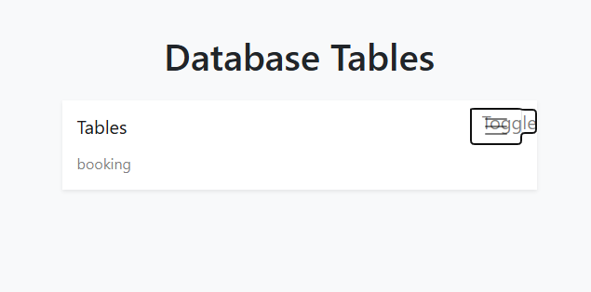
 | Live bus schedules | Service : this page represents the daily bus routes schedules on real time visibility , which shows multiple attributes for the bus fleets , start and end location and arrival times.  Actions (only read) : this action can only let the user to read by scrolling and viewing the schedules to plan their trips , this page is directly connected to the view BusSchedules ensuring the student can view the data without having the privilege to make any change on it . | 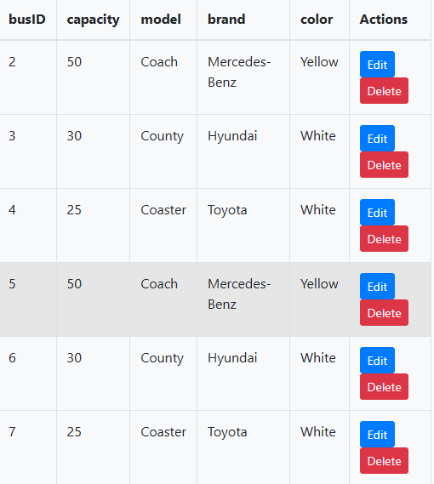
 | Seat reservation form | Service : this page performs the core function for the system where students can reserve their own seats alone on a specific bus online before arriving at the campus.  Action (write) : this action let the student to write and add multiple reservations by selecting the tripID and click on “confirm booking” which will automatically communicates with the backend SQL code to call the insert method into the booking junction table recording the studentID and tripID to set the status “confirmed”. | 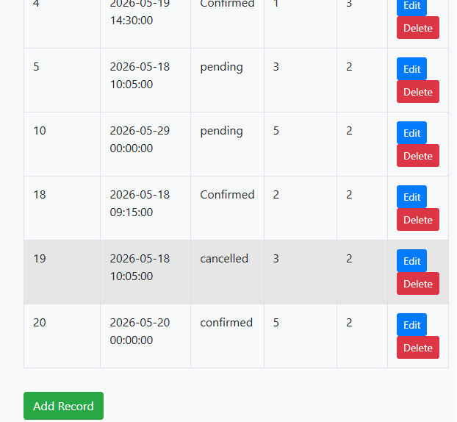
 | My booking and cancellation | Services : this page play the role of personal management tool which filters the DB to only show the existing reserved trips and to have the privilege to edit on each.  Actions (update) : students can view their existing reserved trips and If they no longer need the reserved seat they can click on “cancel seat” instead f deleting the whole record and this securely executed by calling the “CALL sp_CancelBooking(BookingID)” a stored procedure to edit their status. | 

Maintenance

Database recovery & backups
In anu enterprise level application data is the most valuable asset , database backups performed in creating multiple or double copy for the actual schema and records to prevent data loss and in the other side the database recovery performed in restoring that already saved data in to the real life system after system failure occurs. So implementing the automated backup and recovery processes is very important for several criteria :
- Protection against hardware and software failures :
Any hardware device like servers and hard drives and disks can crash and fail also the software system can fails while updating which will led to loosing files and data so without iterative backups process university will lose all students and fleets data.
- Mitigating human errors :
Nirmal or unexperienced agent would accidentally use the command DELETE without setting the main condition WHERE that would erase all active seats and data in seconds so backups let the system to role back before error established.
- Security and ransomware protection :
In any cyberattack or malicious events where data is encrypted or stolen by unauthorized person in the other side of having an offline backup copy will let the IT team to back role the system and restore operations safely.
- Legal compliance and auditing :
For auditing and monitoring purposes from the ministry of transport the historical logs , fleet operations and passenger count data would always be available to prevent any penalties so backups would protect the organization from any penalties to keep the reputation bright that would affect the success of the organization system.

- Steps to export data and schema using the workbench :
- Open MySQL workbench and connect to the server
- Go to the navigation bar in the top of the page , click server then select data export from the pop-up menu.
- In the left panel side under the “tables to export” check the needed schema to be backup then select dump “ structure and data “ This guarantees that both the table designs (structure) and the actual student passenger records (data) are saved. then click to check on “stored procedures and functions” to save the existing procedures in your system.
- In the export section click on “export to self contained file” then choose a secure file to store your data on it like google drive(you can name the file where data will be stored).
- Then click the box “include create schema” this guarantee that the system will rebuild your database structure if the original destroyed.
- Finally , click on start export to generate the backup file.

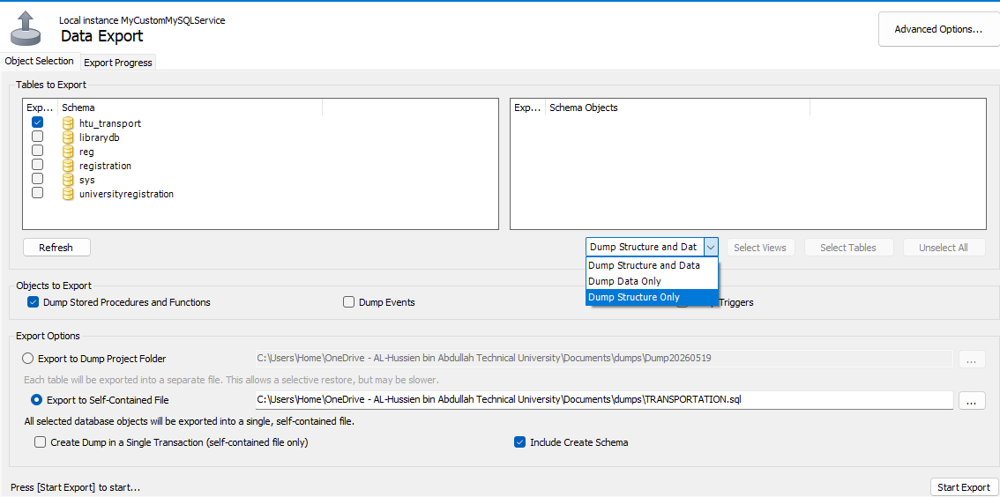

- Steps to import data and schema using the workbench :
- Open MySQL workbench and connect to the server
- Go to the navigation bar in the top of the page , click server then select data import from the pop-up menu.
- In the main window chose the “import from self contained file” radio button , then click the browse button to chose the path of the prestored file on the secure drive.
- Under the “default target schema” select the database name (if the whole schema where deleted click the new button to recreate the empty database shell first).
- Make sure that the “dump structure and data” is selected.
- Click “start import” so the workbench will automatically read the prestored file and rebuild all missing components and reinsert the whole records for students and fleets in the real life system.

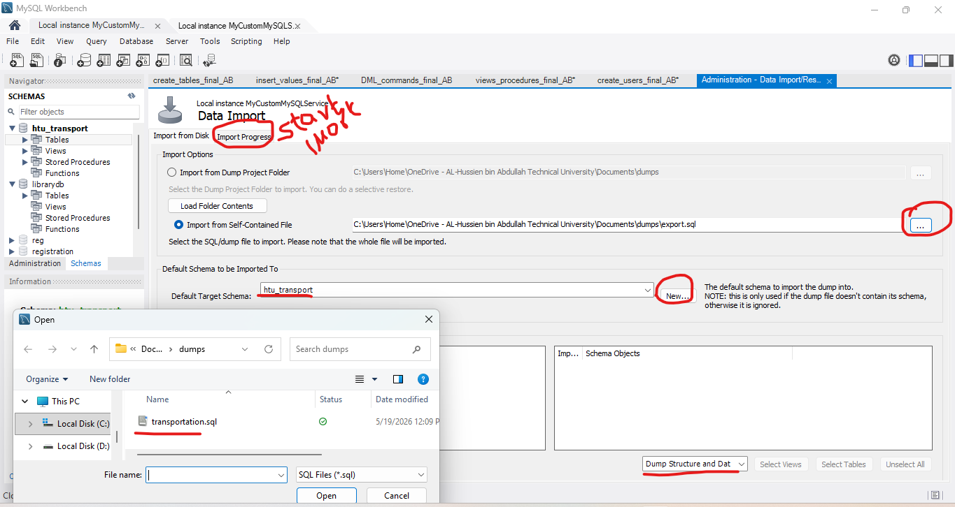

Database maintenance in general .
- Iterative database maintenance in crucial for several reasons that directly affect business continuity and user experience :

- Performance optimization : over time as record numbers begin to extend like bus daily booking are added and removed , thy physical storage of the stored data becomes fragmented , so without iterative maintenance the database will work harder and spend longer time than the normal range to retrieve data leading to slow performance speed in the system so iterative maintenance operation will restore the strong performance of the system .
- Data integrity and reliability : hardware and software glitches , unstable power and other bugs can led to tiny errors in the data files although will iterative maintenance operations will acts as an early warning system and will identify and repair these logical inconsistencies before they impact on the entire system and let it fail.
- Cost efficiency : a well maintained , optimized database uses less CPU power and also less physical storage space on the server so by archiving and storing the old data and optimizing queries organization can postpone the expensive hardware upgrades and software updates.

- Key methods of database maintenance :
To achieve the listed benefits above database admins must employ multiple maintenance methods ,while backups and recovery play the role of reactive operations these methods are the proactive operations for system health :

- Updating database statistics :
The database relies on a tools named query optimizer to figure out the fastest way to execute user requests such as finding a specific bus schedule . the optimizer relies on statistics (a mathematical map of how a data in placed in a table).
The method : as well as huge number of records are added daily , the old statistics become outdated that affect the optimizer to operates slow , inefficient search paths , a critical maintenance method is manually or automatically running commands to update these statistics so the database workbench can easily and with high speed performance make accurate routing decisions.
- Database consistency check :
Physical storage drives can sometimes flip parts of the data causing silent corruption .
The method : admins must run internal consistency checks such as “mysqlcheck” in the MySQL workbench , so these commands would scan the entire database page by page to make sure of the structural and data integrity of all the objects , reporting any broken linkages between tables or corrupted data blocks so they can repaired directly and iteratively.
- Data archiving and purging :
As the database becomes bigger and grows up over years , operation tables become fulfilled with unneeded historical data that is rarely accessed but also it slows sown the entire system and operations.
The method : you can set archiving functions automatically by the automated maintenance tools for example : any data belongs to transportation trip that is older than two years is migrated out of the live trip and booking tables and moved into a unused offline data warehouse for legal auditing so the live and reliable database is then purged from the old data keeping the active system fast and lightweight.

Testing

Data Validation
Number | Type | Description | screenshot
 | All cases of PK | Uniqueness : by running an insert query using busID that already exists we will test the busID PK in the Bus table.  Expected result : it will pass an error (duplicate entry). | 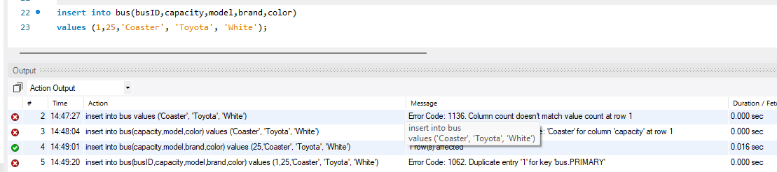
 |  | Not Null : by testing the same PK which is busID in using an update query to set the busID = Null.  Expected result : it will pass another error (column cannot be Null). | 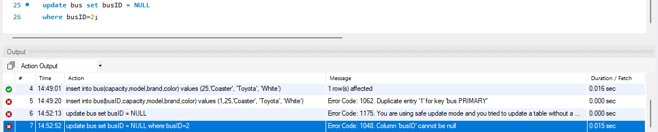
 | All cases of FK | Non existent PK : by inserting a booking record using fake studentID =99 we will be testing studentID FK in the booking table.  Expected result : it will pass an error (cannot add child row) | 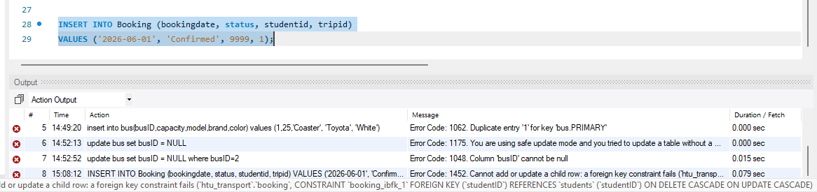
 |  | On delete cascade : I well test the student_phonenumber table that is linked with the PK studentID by deleting the record for student4.  Expected result : it will executes successfully then by using a select command that will represent all the records except student 4 record. | 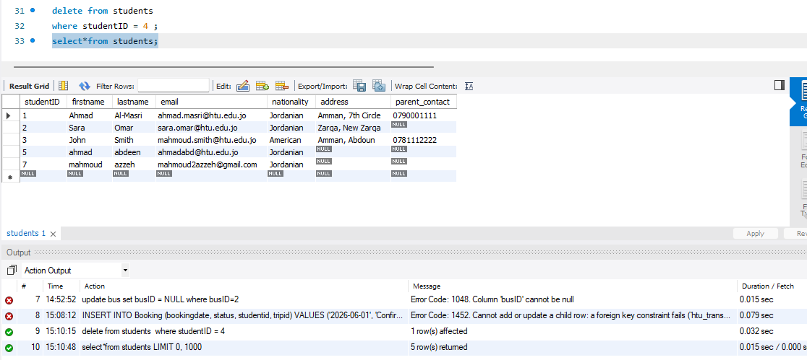
 |  | Restrict : I well try to delete trip1 record to test the tripID FK in booking linked to trip while passengers are booked .  Expected result :it will pass an error with a FK constraints restriction error. | 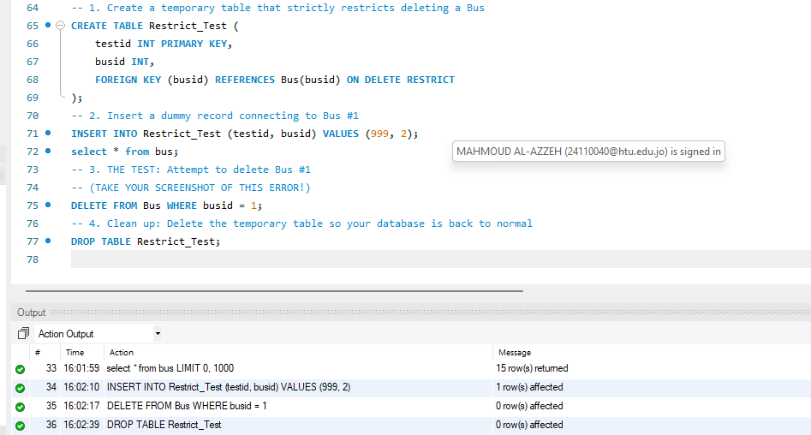
 | Unique | We will test a non PK attribute the email column in the student table by attempting to insert a new student profile using an email address that is already exists to another user  Expected result : The query will fail and will pass an error duplicate entry proving that email remain strictly unique across the system . | 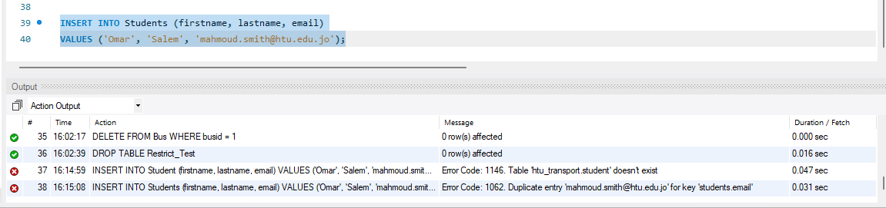
 | Default | By testing the nationality attribute in the student table by using an insert command without writing the value of the attribute because the system is done inside Jordan so it will automatically fill the record.  Expected result : the query will directly fill the attribute with the Jordanian value . | 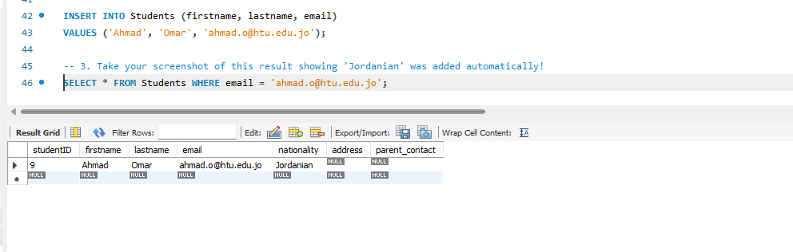
 | Not null | We will test the first attribute in the student table which is firstname by inserting a new record but without writing the firstname and leave it blank  Expected result : the query will fail and it will pass an error because it does not have a default value or a not null constraints to prevent a missing information in profile settings. | 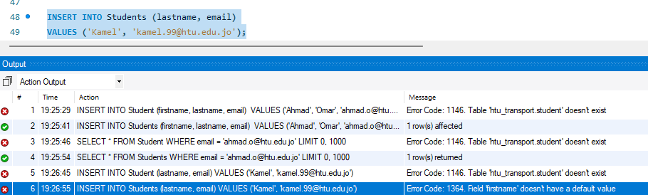
 | Check | By testing the status attribute in the booking table the system expects from the user only one of the three values “confirmed”,”pending”,”cancelled” by using an insert command to add a new record using and invalid input “lost”.  Expected result : the query will fail and the system will pass an error “check constraints is violated” effectively blocking any kind of mismatch that would break the logic of the system. | 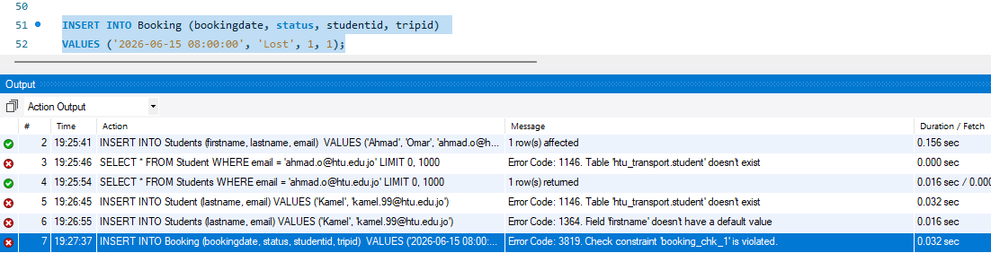

Output Validation
Number | Query Description | Screenshot (query + result) | Result validation
 | Retrieve data using select with where : the purpose is to retrieve the personalized data securely using the database view (vw_StudentBookings) this can help in filtering the results for students without exposing the entire system data. W | 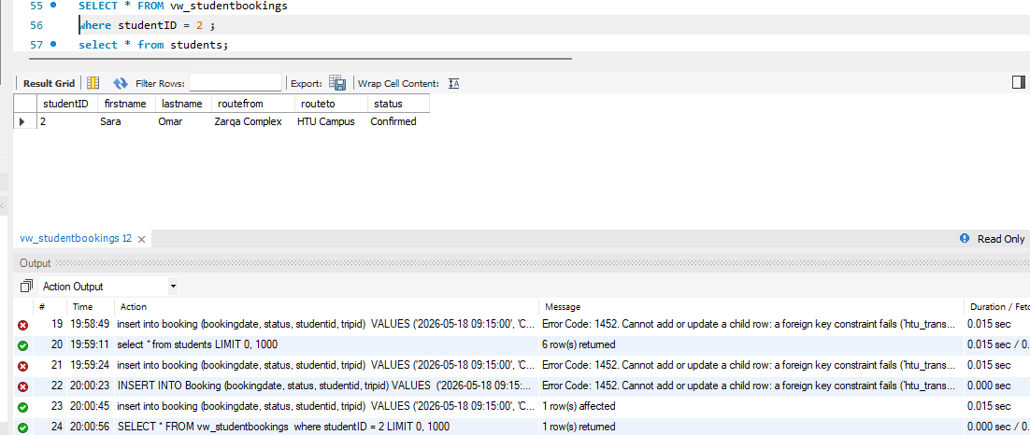 | The query was successfully executed and the result displays the tris booked by studentID 2 , By verifying against the master table, we confirm that no records belonging to other students leaked into this output, proving the WHERE condition perfectly filters the view.
 | Data manipulation : the purpose for this query Is to add newly purchased bus to the fleet and prove that the record is added successfully and available in the system inventory. | 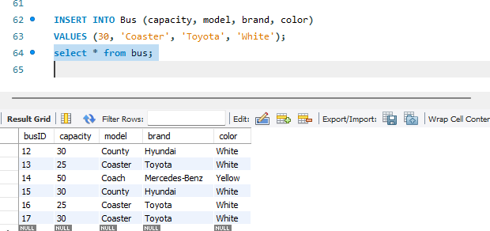 | The insert command was successfully executed where the insert command added the newly vehicle confirming that the database accurately accepted and stored the new vehicle parameters in the correct columns.
 | Data modification : the purpose for this query is to use update to modify an added reservation status from pending to confirm and the second one to delete operation to safely remove a cancelled reservation from the system. | 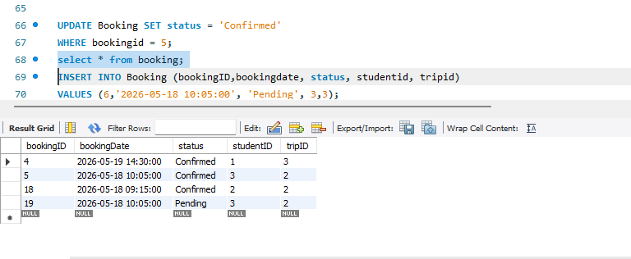  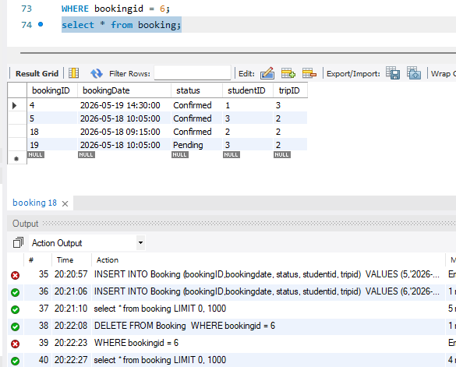 | The screenshot proves that the modification and deleting operations executed successfully and the result shows that the bookingID = 5 status updated to confirmed instead of pending and the deletion also succeed by removing row 6 without accidently dropping the whole table.
 | System analytics : the purpose is to the sum up the total number of customers currently booked on each bus route by using the count aggregation function grouped by tripID to monitor crowding. | 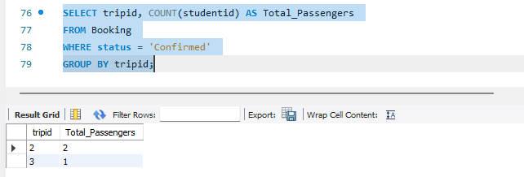 | The output shows a correct result regarding the sum of passengers for each trip by displaying the tripID beside the sum of each passengers (Total_Passengers) , a manual count of the confirmed rows in the table matches the represented number.

Security Validation
Number | Username | Description of privilege/no privilege | Screenshot (query + result)
 | Student user | By testing the explicit select privileges granted to the student for the view that is responsible to display (read) the schedules which the student is authorized to view the data and plan. ` | 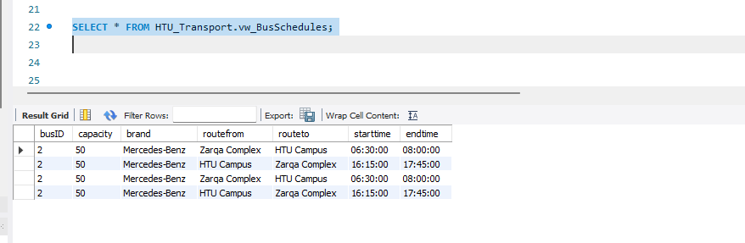
 | Student user | By testing the update privileges granted by the user on the booking table the student is authorized to edit their reservation status from pending to cancelled. | 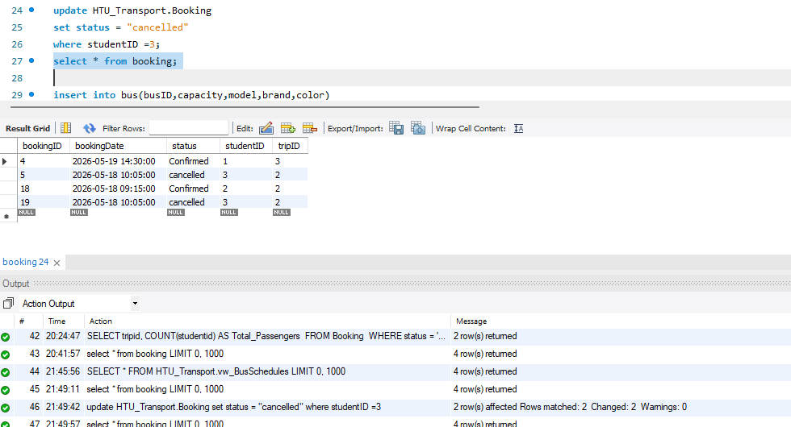

GUI Validation
Number | Description | screenshot
 | Read operation : Objective: Validate that the GUI successfully connects to the database and accurately retrieves information Action: Navigate to the "Student Schedule" or "Data View" screen within the frontend application. | 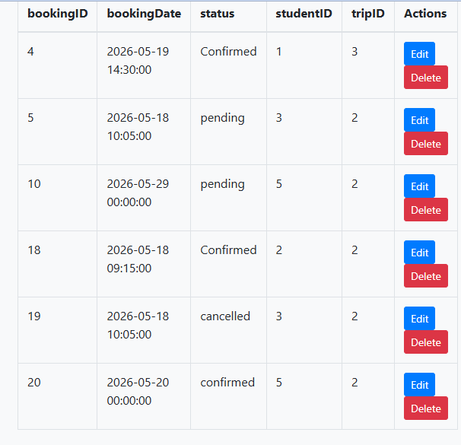
 | Objective: Validate that data entered into the GUI forms is successfully written into the backend database tables. Action: Use the "New Booking" or "Add Student" form in the GUI, fill in the text fields with valid data, and click the "Submit/Save" button. | 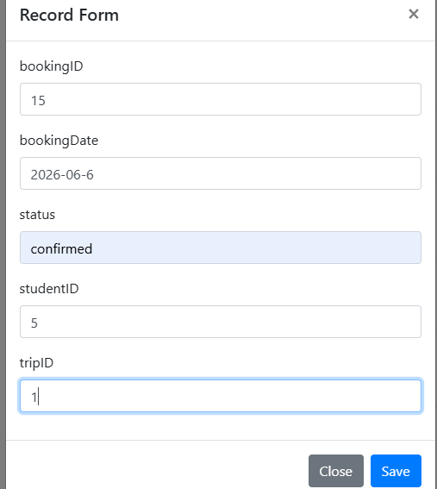  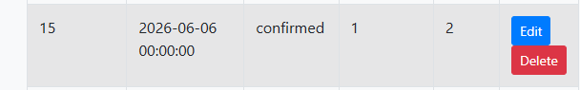
 | Objective: Validate the GUI's ability to safely modify existing database records. Action: Use the administrator interface in the GUI to select an existing booking and change its status from 'Pending' to 'Confirmed' using a dropdown or text field, then apply the change. | 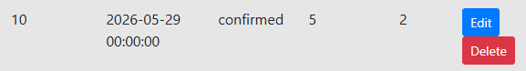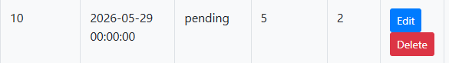
 | Objective: Validate that the GUI correctly respects and reflects the strict CHECK constraint built into the database for the booking status. Action: Attempt to update or submit a new booking using the GUI interface, but intentionally input an invalid status word (such as 'Lost' or 'Delayed') that violates the CHECK (status IN ('Pending', 'Confirmed', 'Cancelled')) rule. | 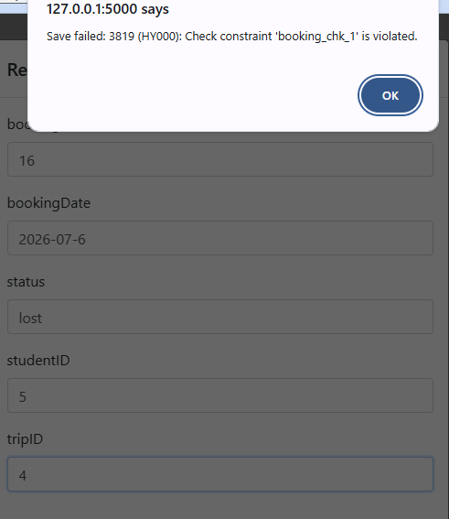

Assess whether meaningful data has been extracted
The actual database system is important as the information it holds , the HTU transport database system is generated and integrated with highly realistic , domain specific data to handle accurate daily operations so we use populated tables with realistic Jordanian student profiles, actual university paths for ex. HTU to 7th circle ) and accurate vehicle specification rather than using generic placeholders like data1 , test A.
So this meaningful naming and specification perfectly illustrate the core relational concept designed within the system:
- Multi valued attributes : in these kind of database designs (relational) all attributes that holds multi values must be separate into its own table as its done in the student_phonenumber table , like : student Ahmad has two separate rows the first one holds his own mobile number and the second one the emergency parent contact which ensures that the university can store multiple of numbers for each student without violating the first stage of normalization.
- On to many (1:M) : this relationship was pointed or discovered over the bus and trip tables , for each single vehicle such as bus 3 (country Hyundai) is responsible to handle multiple trips through the week , and the busID acts as the FK in the trip table which means that one bus can handle many routes but each route is related to one and only one bus.
- Many to many (M:N) : normally students will reserve hundred of trips over their academic years and also each trip will have multiple of students over it so this many to may relationship was solved using the booking table by storing studentID as FK and tripID also as FK and the booking status , so the database effectively maps meaningful records allowing to see exactly which seat on which specific Tuesday morning bus is reserved for ahmad.
Meaningful views and procedures :
Beside the data storage the system utilizes programable objects to transform data into actionable services:
- System views : vw_StudentBookings , this view purpose is to securely combine data from multiple tables which is student and trip and booking tables into one single point of access to be readable daily schedules instead of forcing the users to complex commands like join operation every time the user wants to review his booking.
Beneficiaries : students can benefit from providing a clean personalized dashboard of their upcoming commutes while simultaneously acting as a security shield that prevents them from querying the raw tables and protect their data over unauthorized access from another students.

- Stored procedures : sp_CancelBooking , this procedure purpose in to automated business logic safely when a user decides to cancel or drop their own seat but by running a normal delete command would accidently erase the entire table records , but this procedure executes an update command on the status to cancelled while keeping the row intact .
Beneficiaries : administrators can benefit from protecting the integrity and availability for the data , transportation managers and legal auditors can also review how many cancellation occurs over the system without losing the financial or operational paper trail.

Assess the effectiveness of testing
The significant of testing databases : the development of relational systems does not conclude with the final line of SQL code but with exactly validation , we benefit of testing databases in its ability to bridge the gap between the theoretical design and the real user interaction world , so out HTU transportation system requires comprehensive testing to ensure that all functionalities are stable and operating successfully , testing is the only method to prove that the system adapting and performing as the given rules to keep data safe and maintains data integrity before publishing over the university.

Steps followed in the testing phase :
To have an efficient and effective testing phase we have separated this process into four critical parts as mentioned previously in the report :

- Structural integrity (FK,PK) : the first step was to fill the tables with the appropriate data then by testing the PK , busID by trying to insert duplicate and Null values and the FK by trying to insert orphan records that are not inserted before like booking for non existing student.
Importance : this is a crucial step in testing because it guarantee that every record in uniquely identifiable and properly linked which prevent the system from unorganized data.
- Business logic validation (constraints) : the second step is involved in testing the attributes constraints like (unique , default , not null, check) I iteratively tried to insert wring data like negative value for bus capacity and incomplete passenger profiles .
Importance : this phase of testing ensures that the system in defending over multiple human inserting errors and proves the database system automatically reject illogical data without requiring intervention from an administrators.
- Output and functional validation : the third phase of testing benefit use by verifying the system operates successfully through data manipulation language. By running multiple commands like , insert , delete and update followed by complex aggregation : (group by) and filtering views by using (where).
Importance : this benefit us by proving that the system is not just place to store data but functional engine capable to accurately calculating route crowding and generating personalized student trip plans .
- Security and access control validation : the final phase of testing was crucial to control and monitor the authorized access for restricted users and attempting to logging unauthorized users and actions.
Importance : this step considered as an ethical and legal step of verifying the role based access control (RBAC) design is actively functioning to shield the system from unauthorized manipulation.

Identified bugs , security issues and errors :
- Closing security vulnerabilities : this phase validates from the importance of database views when testing the student user account I tried to query the raw student table directly , and the output was that the system throws an error , had this testing phase been skipped , a misconfigured permission could cause a less security allowing any student to delete phone numbers and private email for others.
- Identified data bugs : finally by testing the check and unique constraints prevented logical bugs that would have affect and damage the fronted GUI , by attempting to insert more than one email address or same email for another student so this confirmed that the database would block the creation of cloned user accounts which prevent the bug of having two students having the same account information that would affect the schedules .

Evaluation of database solution

Effectiveness of the database solution based on user and system requirement
The development oof our transportation database was driven by a critical necessity with a secure centralized digital system rather than manual logistical processes , over the done evaluations we discovered that the database successfully fulfils its primary objectives : to manage the systems fleet , accurately schedule daily reservations and comprehensively protect data by transforming from a basic conceptual design to a fully functional relational design , the result provides highly reliable , automated foundational for the university daily transportation operations.
When mapping between the initial requirements and the final product we will find that the database demonstrates a remarkable degree of structural alignment . one of the most important requirements was to let the students reserve their own seats on specific routes within the implementation of robust many to many relational design ,using a dedicated booking table to handle all reservations without causing any duplication . also implementing some strict business rules on the system to protect the integrity of the data by applying constraints directly into the schema , for example : capacity constraints prevent a mathematical issue if the user tries to enter a negative value and prevent buses from overbooking and uniqueness prevent the creation of cloned student profile data. Also this database was iteratively evaluated and assessed to ensure it fits the university reality requirements, through the strategic use of system views and procedures it met the requirements of providing personalized daily plans to users while protecting admin tables from unauthorized access.
Despite all the crucial technical requirements there were an important requirement from the initial phase of developing and planning for the system that must be acknowledged that the student must receive an SMS notification if any issue occurs regarding any reservation and alert the student before the time exists ,but unfortunately this feature was not achieved in the current database iteration , and the primary reason for not implementing this feature is that our workbench MySQL dies not support this kind of services of sending an SMS notification for the user without any help or provided backend programming language consequently our system relies only on frontend application to present nay changed status on booking.
In the other hand , normally while the normalization and development phases new requirements were discovered that were not honestly mentioned in the initial phases , the most important requirement that was discovered was introduction of a dedicated status-tracking system within the reservations. At the first conceptual design was to simply let the student delete all the record of the reservation , however to maintain a reliable operational audit trial for university administrators a distinct status attribute capable of registering either “pending”, ”confirmed”, ”cancelled” was newly integrated through the design which ensure analytics for historical cancelled reservation over one academic year , additionally, strict data normalization rules dictated the unexpected creation of a separate, dedicated table for student phone numbers. This was incorporated to handle multiple emergency contacts per student, ensuring the entire system adhered flawlessly to the rules of First Normal Form (1NF).

Suggested improvements
While the current transportation system successfully meets its functional objectives for planning trips and data integrity an objective review discovered that there are many areas could be enhanced , to transition this system from a functional academic project to a real world ready logistic platform , specific shortcoming in business operations like deep security and scalability over years must be addressed.
- Design and entity additions (business and operational aspects) :
Current shortcoming : the database accurately tracks the vehicles bus table and the routes trip table , but it completely miss human operational tracking for the staff that drives the vehicles .
Suggested improvement : introduce a new driver entity (with multiple attributes : driverID , name , license_Expiry , shift hours). This would make us process and handle a one to many relationship between driver table and trip table.
Reasoning : perceiving the process from the business side these kind of systems relies on human resources , if a student reports reckless driving or a bus is delayed , the administration have no information about who is driving each bus , and by adding this entity closes a massive operational blind spot.

- Attribute expansion (financial and maintenance aspects) :
Current shortcoming : the system treats every transport reservation as a purely logistical event ignoring all financial and material products related in consumption and operating transport network.
Suggested improvement : add some attributed to the trip table like ticket_price and last_maintenance_date to the bus table, in addition to , a new entity payment could be linked to booking table to track student subscription or individual ticket purchased.
Reasoning : even if the university provides student travel , the management office must track the financial value of these routes to calculate operational budgets , and to track maintenance dates directly within the database admins to keep transport safe without risk of damages.

- Security enhancements :
Current shortcoming : our system uses the role based access control and database views to prevent unauthorized access on the system however this lacks the opportunity of tracking the authorized access control and movement in the internal system.
Suggested improvement : we can implement an audit_log table combined with system database trigger , in any time admins run any delete or update command like cancelling trip or modifying already existing record a trigger should directly record the users ID , timestamp and the exact date the changes occurs into the audit_log
Reasoning : if a case of deleting a whole record for multiple tables accidently or any database network breach from the entire corporate ,RBAC will not detect it because the user have a legal access on the system , so the audit_log provides the absolute forensic accountability which a mandatory condition for corporates which deals with personal data.
- Scalability optimization :
Current shortcoming : the junction booking table currently designed as a standard table , over time thousand of students reserve trips daily this single table will fulfils with million of records over multiple semesters which will resulting in low performance .
Suggested improvement : by applying a new portioning table beside the booking table , dividing the physical storage of the data by academic semester or year .
reasoning : scalability features need proactive data management by splitting the table into multiple parts the database engine will not have to scan multiple years of historical data just to load a new day bus schedule , so this optimization ensures that the speed remain lighting fast on the frontend application regardless of the new design of the datasets over the new decades .

Evaluation based on improvements needed
All the possible improvements mentioned in section 9.2 are designed to improve the HTI transportation database from a basic system to a fully functional enterprise management system, however applying these improvements on the system requires a highly analysis of the impact on the systems overall.
- Potential benefits of implementation :
Applying the possible improvements would yield massive benefits across functionalities , security and long term performance.

1. enhanced operational completeness : By introducing payment and driver entities, the database becomes handling all operations . Admins would no longer need separate software to track staff shifts or student ticket payments. This centralization make less admin error and make sure that all university transportation data is stored in one place.
2. Proactive Maintenance and Safety: adding new attribute like last_maintenance_date to bus table switch the system from precative to proactive system. It allows the system to automatically flag vehicles that are legally or mechanically unsafe to operate, directly protecting student safety.
3. Absolute Security Accountability : audit_log powered by database triggers provides guard layer of security. If a malicious data deletion occurs, admins will have an exact record of who executed the command and when the process occurs ensuring total accountability over the system.
4. Sustained High-Speed Performance: by separating tables (partitioning ) on the booking table guarantees that the system remains fast. By separating old historical bookings from current active ones, the database engine can execute daily schedule queries instantly, even if any changed on data set occurs.

- Challenges and technical trade_offs :
1. Increased Development Time and Complexity: Adding new tables means rewriting the existing database views and frontend application queries to accommodate more complex operations like join commands. also writing secure, bug free triggers for the audit_log requires advanced Database Admins (DBA) that have years of experience, which will extend the development timeline.
2. Additional Storage and Resource Requirements : by applying active audit_log acts as a double layer of data protection, while it secures the system, it also means the database will consume physical storage space at a much faster rate, as every single modification occurs. This may let the university to put more budget on cloud storage or additional physical servers.
3. Maintenance Overhead: separating tables ,however it is excellent for performance, requires ongoing maintenance. Future DBAs will need to actively manage and create new partitions every new academic year or semester , increasing the responsibilities on admins to keep the database running smoothly.

Comprehensive assessment conclusion :
Finally, the impact of these improvements will affect the system positively. While applying these phases requires more time, financial resources, and architectural complexity, the return on investment is crucial. The trade-offs of requiring more storage space and advanced coding are heavily outweighed by the resulting benefits: a perfectly secure, infinitely scalable, and operationally complete transportation network that can safely serve the university for years to come.

User Documentation

System Overview
Welcome to HTU student transportation system , this system is designed to help you in your daily commuting to and from the university as comfortable and organized as possible. The primary purpose of the implemented system is to let students to look at the real time bus schedules and reserve their seats in advanced ensuring a safe and guarantee journey.
The user perceive the system as a digital ticketing and management hub, it stores student profiles and bus fleet information regarding the university needs , daily schedule journeys and individual student reservation, the system architecture is designed to be highly secured and user friendly , which allow the student to only see their relevant daily journeys while the other side , administration can access the fleet management , bus capacities and other tools to ensure all buses are operating safely and within legal capacities.

Using the system

User role : student.
Task 1: viewing the bus schedule :
- Log into the HTU transportation portal using your university email and password.
- Upon logging in , you will be directed to the homepage.
- Click on the “view schedules” tab located on the main navigation menu.
- The screen will list the whole available routes , including the starting location , destination, and departure time for the day.
- Screenshot :
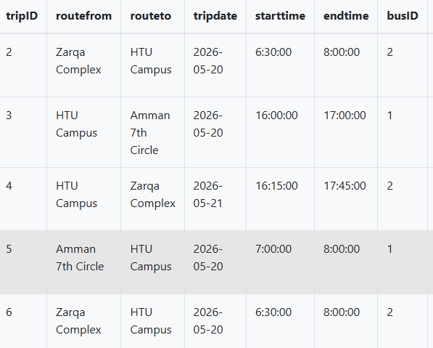
Task 2:
- From the schedule page you can pick the suitable trip.
- Click the book seat button next to your desired trip.
- A confirmation pop-up will appear summarizing your route and time.
- Click “confirm reservation”.
- The system will automatically store you reservation info and set the status to “confirmed” with a note : the bus has not reach the maximum capacity.
- Screenshot :
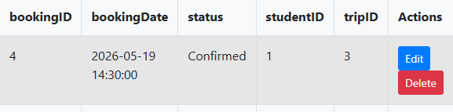
Task 3:
- Navigate to the my booking shelf from the main page.
- It will represent all your upcoming and past trips.
- Locate the unneeded trip and press cancel booking and it will be removed from your schedule.
- Your seat will return available and be ready to be reserved from another student with a status “cancelled ”.
- Screenshot :
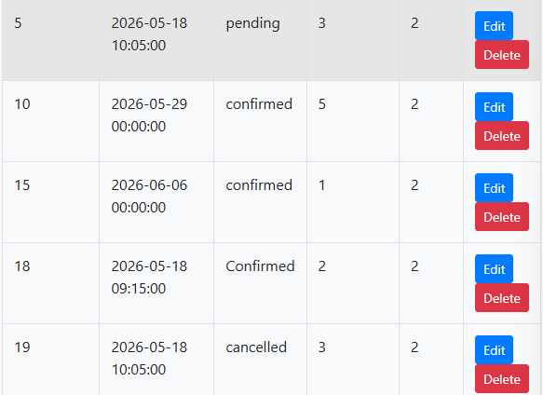

Frequently asked questions :

- Q : How to ensure that the reservation was successfully done ?
A : Once to finish booking your trip you can go the navigation tab “my booking” and check if the status beside the trip is “confirmed” so this guarantee that your trip is successfully reserved and if not you can recheck with the customer service team.

- Q : Can I book two trips in the same time and bus ?
A : no , for safety issues and capacity tracking your account is strictly tied to your personal student ID so every student must log into his account to reserve his own trip.

- Q : what happens if the capacity limit hits ?
A : the system is designed to prevent overbooking based o each bus capacity limit so if one bus reach his capacity limit the book seat button will be disabled automatically and you will need to choose another alternative trip time .

- Q : can I modify my info on the portal like my mobile number ?
A : yes , by going to the profile setting navigation you can add a new mobile number or delete the current one also the system allow you to store multiple of phone number at the same time.

Contact information
If the user experienced or faced any technical bugs or issues with the transportation portal , or if their any questions regarding any service , please reach out to our support customer team :
- Technical support email : ITsupport@htu.edo.jo
- Transportation office mobile number : +962 500 6000
- Working hours : Sunday to Thursday (8:00 am to 5:00 pm)
- Online resources : you can also provide any expected question using our online student forum at “community.htu.edu.jo/transport” , you can also report lost items on fleets or share your feedback over your experience whether its lovely or incredible.

References :

“GeeksforGeeks (2024). MySQL Database Maintenance Best Practices. [online] GeeksforGeeks. Available at: https://www.geeksforgeeks.org/mysql/mysql-database-maintenance-best-practices/.”

“1902 Software. (2026). How to improve database performance with effective strategies. [online] Available at: https://1902software.com/resources/custom-software/improve-database-performance/.”

“GeeksforGeeks (2025). Database Security. [online] GeeksforGeeks. Available at: https://www.geeksforgeeks.org/dbms/database-security/.”

‌“GeeksforGeeks (2020). Difference between Flowchart and Data Flow Diagram (DFD). [online] GeeksforGeeks. Available at: https://www.geeksforgeeks.org/software-engineering/difference-between-flowchart-and-data-flow-diagram-dfd/.”

“GeeksforGeeks (2025). Database design in DBMS. [online] GeeksforGeeks. Available at: https://www.geeksforgeeks.org/dbms/database-design-in-dbms/.”

“GeeksforGeeks (2015). Introduction of Database Normalization. [online] GeeksforGeeks. Available at: https://www.geeksforgeeks.org/dbms/introduction-of-database-normalization/.”

“GeeksforGeeks (2017). Database Recovery Techniques in DBMS. [online] GeeksforGeeks. Available at: https://www.geeksforgeeks.org/dbms/database-recovery-techniques-in-dbms/.”

